LAB ASSIGNMENT – 4.1

NAME : Y UMENDER REDDY
HALL.NO : 2403A52371
BATCH.NO : AI 13

ASSIGNMENT : 4.1

PROMPT 01 :
i need a python code function that validates an Indian mobile number. Requirements
The function must ensure the mobile number:
Starts with 6, 7, 8, or 9
Contains exactly 10 digits

CODE :
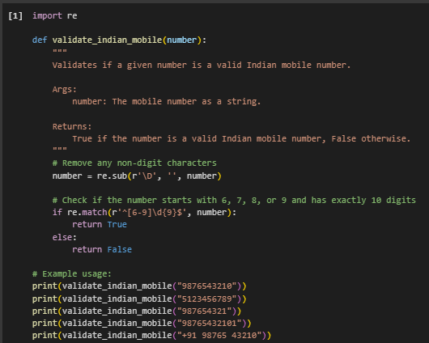
OUTPUT :
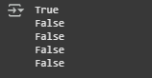
- CODE EXPLANATION :
import re: This line imports the re module, which provides support for regular expressions in Python. Regular expressions are used here to define a pattern for matching valid mobile numbers.
- def validate_indian_mobile(number):: This defines a function named validate_indian_mobile that takes one argument, number, which is expected to be the mobile number string you want to validate.
- number = re.sub(r'\D', '', number): This line uses a regular expression \D to find and remove any non-digit characters from the input number string. This cleans the input so that only digits remain for validation.
- if re.match(r'^[6-9]\d{9}$', number):: This is the core validation step.
  - re.match() attempts to match the regular expression pattern from the beginning of the cleaned number string.
  - ^[6-9] matches the start of the string (^) followed by a single digit that is either 6, 7, 8, or 9.
  - \d{9} matches exactly 9 digits (\d matches any digit).
  - $ matches the end of the string.
  - So, the entire pattern ^[6-9]\d{9}$ ensures the number starts with 6, 7, 8, or 9 and is exactly 10 digits long.
- return True: If the regular expression matches the cleaned number string, the function returns True, indicating a valid Indian mobile number.
- else: return False: If the regular expression does not match, the function returns False, indicating an invalid Indian mobile number.
- print(...): These lines demonstrate how to call the validate_indian_mobile function with different example numbers and print the returned boolean result (True or False).

PROMPT 02 :
i need a python code function that calculates the factorial of a number. Requirements • Provide one sample input-output pair in the prompt to guide the AI. • The function should handle: o 0! correctly o Negative input by returning an appropriate message

CODE :
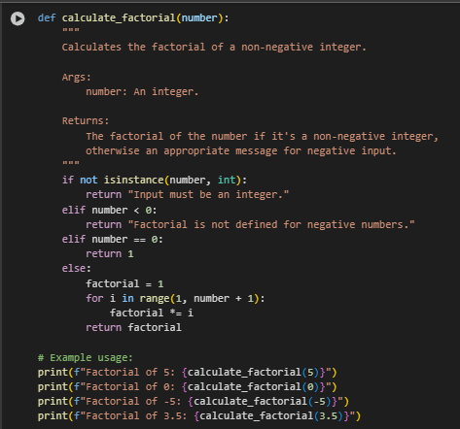

OUTPUT :
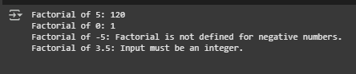

CODE EXPLANATION :
- def calculate_factorial(number):: This defines a function named calculate_factorial that takes one argument, number, which is the integer for which you want to calculate the factorial.
- if not isinstance(number, int):: This checks if the input number is not an integer. If it's not an integer, it returns the message "Input must be an integer."
- elif number < 0:: If the number is an integer but is less than 0, this condition is met, and the function returns the message "Factorial is not defined for negative numbers."
- elif number == 0:: If the number is an integer and is 0, this condition is met, and the function returns 1, because the factorial of 0 is defined as 1.
- else:: If the number is a non-negative integer (greater than 0), this block of code is executed.
  - factorial = 1: Initializes a variable factorial to 1. This is the starting point for the calculation.
  - for i in range(1, number + 1):: This loop iterates from 1 up to and including the input number.
  - factorial *= i: In each iteration, the current value of factorial is multiplied by the loop variable i. This performs the cumulative multiplication for the factorial.
  - return factorial: After the loop finishes, the final calculated factorial value is returned.
- print(f"Factorial of...: These lines are examples of how to call the calculate_factorial function with different inputs (5, 0, -5, and 3.5) and print the results, including the informative messages for invalid inputs.

PROMPT 03 :
i need a python code with 2 to 3 examples function that parses a nested dictionary representing student information. Requirements • The function should extract and return: o Full Name o Branch o SGPA

CODE :
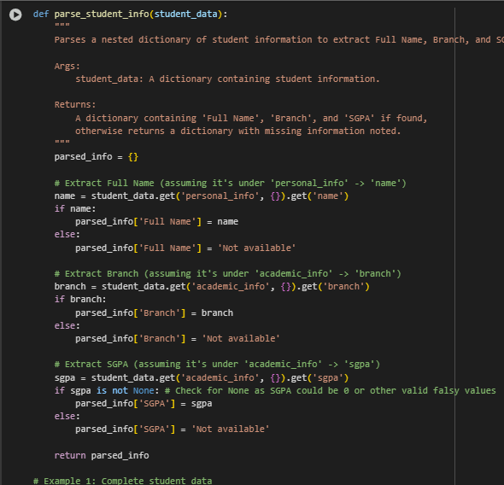
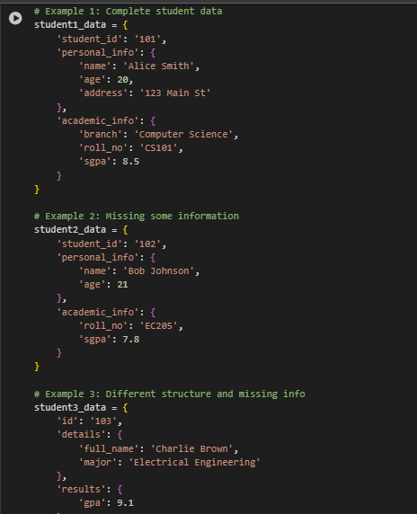
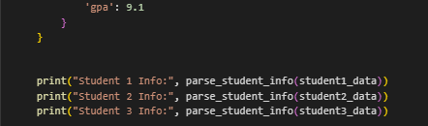

OUT PUT :
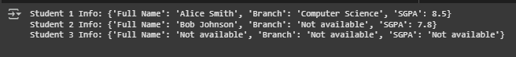

CODE EXPLANATION :
- def parse_student_info(student_data):: This defines a function named parse_student_info that takes one argument, student_data, which is the nested dictionary containing the student's information.
- parsed_info = {}: Initializes an empty dictionary called parsed_info. This dictionary will store the extracted 'Full Name', 'Branch', and 'SGPA'.
- name = student_data.get('personal_info', {}).get('name'): This line attempts to extract the student's name.
  - student_data.get('personal_info', {}) safely tries to access the 'personal_info' key from the student_data dictionary. If 'personal_info' doesn't exist, it returns an empty dictionary {} to prevent an error.
  - .get('name') then safely tries to access the 'name' key from the result of the previous step. If 'name' doesn't exist (either because 'personal_info' was missing or 'name' was missing within it), it returns None.
- if name:: This checks if the extracted name is not None and is a truthy value (like a non-empty string).
- parsed_info['Full Name'] = name: If a name was found, it's added to the parsed_info dictionary with the key 'Full Name'.
- else: parsed_info['Full Name'] = 'Not available': If no name was found, 'Not available' is added to parsed_info for 'Full Name'.
- branch = student_data.get('academic_info', {}).get('branch'): Similar to extracting the name, this line safely attempts to extract the 'branch' from the 'academic_info' nested dictionary.
- if branch:: Checks if a branch was found.
- parsed_info['Branch'] = branch: If a branch was found, it's added to parsed_info.
- else: parsed_info['Branch'] = 'Not available': If no branch was found, 'Not available' is added for 'Branch'.
- sgpa = student_data.get('academic_info', {}).get('sgpa'): Safely attempts to extract the 'sgpa' from the 'academic_info' nested dictionary.
- if sgpa is not None:: This checks if the extracted sgpa is not None. It specifically checks for is not None because sgpa could be 0, which is a falsy value in Python, but a valid SGPA.
- parsed_info['SGPA'] = sgpa: If an SGPA (including 0) was found, it's added to parsed_info.
- else: parsed_info['SGPA'] = 'Not available': If no SGPA was found (i.e., it was None), 'Not available' is added for 'SGPA'.
- return parsed_info: The function returns the parsed_info dictionary containing the extracted (or 'Not available') information.
- student1_data = {...}, student2_data = {...}, student3_data = {...}: These are example dictionaries representing different student data structures and missing information.
- print("Student 1 Info:", parse_student_info(student1_data)): These lines demonstrate calling the parse_student_info function with the example data and printing the resulting dictionaries.

PROMPT 04:
i need a pyhon code functions for CSV file analysis. Requirements • Each generated function should: o Read a .csv file o Return the total number of rows o Count the number of empty rows o Count the number of words across the file

CODE :
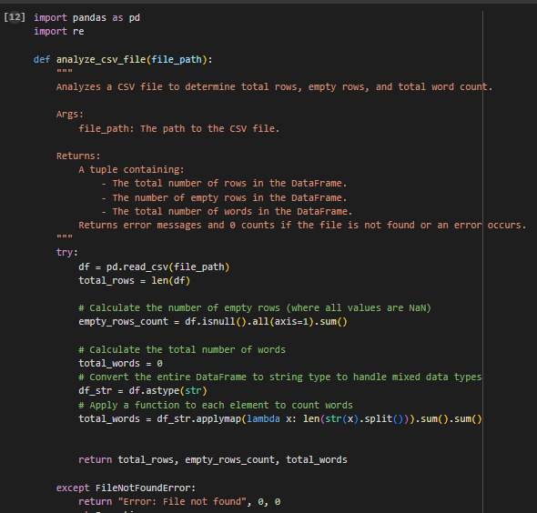
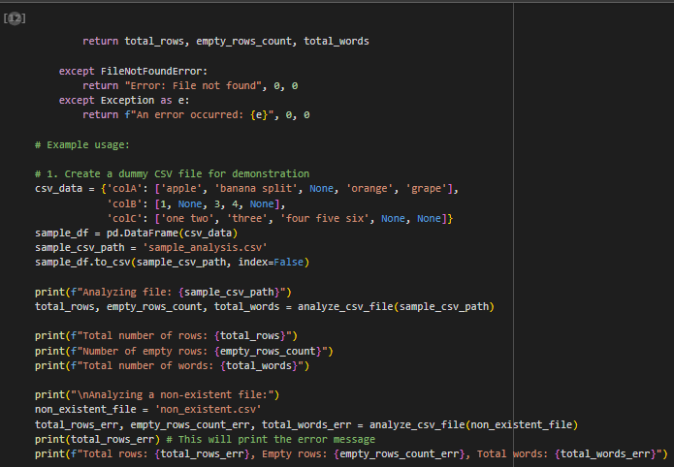

OUTPUT :

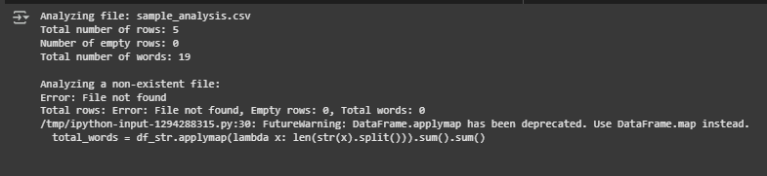

- CODE EXPLANATION :
import pandas as pd: This line imports the pandas library, which is essential for working with DataFrames and reading CSV files, and assigns it the alias pd.
- import re: This line imports the regular expression module, although it's not directly used in the final version of the analyze_csv_file function provided. It was likely included in an earlier iteration of combining code.
- def analyze_csv_file(file_path):: This defines a function named analyze_csv_file that takes one argument, file_path, which is the path to the CSV file you want to analyze.
- try...except FileNotFoundError...except Exception as e:: This block handles potential errors during file processing.
  - It attempts to execute the code within the try block.
  - If a FileNotFoundError occurs (meaning the specified file doesn't exist), it returns an error message "Error: File not found" and 0 for the counts.
  - If any other Exception occurs during the process, it catches it and returns a generic error message including the exception details and 0 for the counts.
- df = pd.read_csv(file_path): Inside the try block, this line reads the CSV file specified by file_path into a pandas DataFrame named df.
- total_rows = len(df): This calculates the total number of rows in the DataFrame df using the len() function and stores it in the total_rows variable.
- empty_rows_count = df.isnull().all(axis=1).sum(): This calculates the number of empty rows.
  - df.isnull() creates a boolean DataFrame where True indicates a missing value (NaN).
  - .all(axis=1) checks if all values across each row (axis=1) are True (i.e., if the entire row is null).
  - .sum() counts the number of True values, giving the count of empty rows.
- total_words = df.astype(str).applymap(lambda x: len(str(x).split())).sum().sum(): This calculates the total number of words across all cells. Note: As mentioned in the previous response, applymap is deprecated and map is recommended for future use.
  - df.astype(str) converts all DataFrame elements to strings.
  - .applymap(lambda x: len(str(x).split())) applies a function to each cell (applymap). The function lambda x: len(str(x).split()) splits the string in a cell by whitespace and counts the resulting words.
  - The first .sum() sums the word counts within each column.
  - The second .sum() sums the column totals to get the grand total word count for the DataFrame.
- return total_rows, empty_rows_count, total_words: The function returns a tuple containing the calculated total rows, empty rows count, and total words.
- Example Usage Block: This part of the code demonstrates calling the analyze_csv_file function with a created sample CSV file and a non-existent file to show the results and error handling.

PROPT 05 :
i need a python code function that processes text and analyzes word frequency. Requirements The function must: • Accept a paragraph as input • Convert all text to lowercase • Remove punctuation • Return the most frequently used word

CODE :
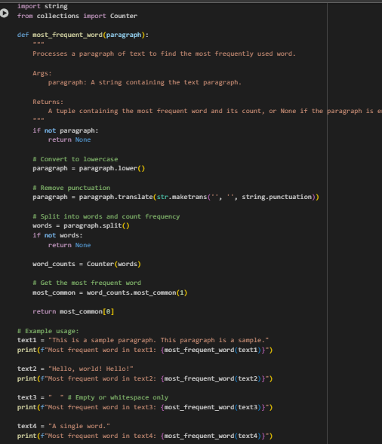

CODE EXPLANATION :
- import string: This line imports the string module, which provides a collection of string constants, including string.punctuation which is used here to get a string of all punctuation characters.
- from collections import Counter: This line imports the Counter class from the collections module. Counter is a specialized dictionary subclass for counting hashable objects (like words).
- def most_frequent_word(paragraph):: This defines a function named most_frequent_word that takes one argument, paragraph, which is the text string you want to analyze.
- if not paragraph:: This checks if the input paragraph is empty or None. If it is, the function returns None.
- paragraph = paragraph.lower(): This line converts the entire paragraph string to lowercase. This ensures that words like "The" and "the" are treated as the same word.
- paragraph = paragraph.translate(str.maketrans('', '', string.punctuation)): This line removes punctuation from the paragraph.
  - str.maketrans('', '', string.punctuation) creates a translation table that maps each punctuation character to None, effectively telling translate to remove them.
  - .translate(...) applies this translation table to the paragraph string.
- words = paragraph.split(): This line splits the cleaned paragraph string into a list of individual words using whitespace as the delimiter.
- if not words:: This checks if the words list is empty after splitting (which could happen if the input was just punctuation or whitespace). If it's empty, the function returns None.
- word_counts = Counter(words): This creates a Counter object named word_counts from the list of words. The Counter automatically counts the occurrences of each word.
- most_common = word_counts.most_common(1): This calls the most_common() method on the word_counts Counter. most_common(1) returns a list containing a single tuple, where the tuple contains the most frequent word and its count.
- return most_common[0]: The function returns the first (and only) element of the most_common list, which is the tuple containing the most frequent word and its count.
- text1 = "...", text2 = "...", etc.: These lines define example paragraph strings.
- print(f"Most frequent word in...: These lines demonstrate calling the most_frequent_word function with the example texts and printing the results.

